**Project Management**

**Discipline Document**

**INF-F Analysis and Software Design**

Project Initiation Document

**Project: Schedule App Hague University**

**Date: 13-2-2014**

**Owner:** ***van Damme, Djastin. Lustenhouwer, Wim***

**Version: 1.0**

**Document History**

**Revision History**

|  |  |  |
| --- | --- | --- |
| **Version** | **Revision date** | **Summary of changes** |
| 1.0 | 02-21-2014 | Final version |

**Distribution**

This document is intended for:

|  |  |  |  |
| --- | --- | --- | --- |
| **Name** | **Function** | **Date of issue** | **Version** |
| van Aalten, Jos | Client | 21-2-2014 | 1.0 |
| Wieman, Anneke | Process advisor | 21-2-2014 | 1.0 |
| Maas, Juul | Business consultant | 21-2-2014 | 1.0 |
| Lustenhouwer, Wim | Project Manager | 21-2-2014 | 1.0 |
| van Damme, Djastin | Project Co-Manager | 21-2-2014 | 1.0 |

Table of Contents

1. Project Definition 4

1.1 Background 4

1.2 Project objectives 4

1.3 Project scope 4

1.4 Interested parties/stakeholders 4

1.5 Constraints and assumptions 5

1.6 User interfaces 5

2. Project Approach 6

2.1 Group-side 6

2.2 Client-side 6

2.3 Business Case 6

3. Project Management Team Structure 8

4. Role Descriptions 9

5. Quality Management Strategy 10

5.1 Introduction 10

5.2 Quality Management Procedure 10

5.2.1 Quality expectations from the clients perspective 10

5.2.2 Acceptation Criteria 10

5.2.3 Quality Control 10

5.3 Roles and Responsibilities 10

6. Configuration Management Strategy 11

7. Communication Management Strategy 12

8. Project Plan 13

8.1 Inception phase 13

8.2 Elaboration phase. 13

8.2.1 IT-1 13

8.2.2 IT-2 13

8.2.3 IT-3 14

8.3 Timeline 14

8.4 General planning 15

1. Project Definition

1.1 Background

The Hague University divides an academic year into four segments. Each of these segments is ten weeks long and is called a term.

Terms are filled with courses overseen by individual course managers. These courses consist of various tasks to be performed by the staff. These tasks are further divided into activities, e.g., specific classes or labs. Before a term starts each course manager creates a Course Parameter System (using Microsoft Excel) which contains all tasks and activities pertaining to that course. The course manager then hands in the CPS to the academy's team leader.

Eight weeks before the start of a term, the team leader compiles all CPS’s for the coming term into a single document called the mastersheet. The mastersheet now contains every task to be assigned in a term. The team leader then assigns all tasks to teachers of his team, taking each teacher’s personal tasks, qualities and availability into account. When each task has been assigned, the relevant information is sent to the HHS’s scheduling department, which will then compile a complete schedule for the term.

Teachers can view their individual tasks for a term by referencing their personal task overview (PTO). These PTO’s are drawn manually from the mastersheet and processed into separate Microsoft Excel files.

The entire process is done manually and therefore very labour intensive and error prone. This led to the desire for a sophisticated digital solution.

1.2 Project objectives

The objective of the system is to replace the manual labour of creating CPS’s, mastersheets and PTO’s with a digital solution. By doing this, the system will save time and by extension will cut costs. Additionally, communications within the organisation will be shortened by a significant amount.

The system will increase the efficiency of management processes through reports and overviews.

1.3 Project scope

The scope of the project is limited to *designing* the solution as the actual construction will be off-shored to India. Therefore it is important that the design will be complete and fully documented.

1.4 Interested parties/stakeholders

Parties involved in this project are: the university, the project group and the coding company in India

The university is the client for this project and employs the following stakeholders:

* Academic for IT & Media
* Course manager
* Team manager
* Teachers
* Students
* Scheduling department
* Webber

The project group consists of eight members who are divided into four disciplines:

* Team management
* System analysts
* Test managers
* Software engineers

As of writing, the coding company in India has yet to be designated and will therefore be omitted from this document.

1.5 Constraints and assumptions

*Constraints*

The crafting of timetables is managed by the scheduling department. This department has set rules for their input which the output of our software has to match.

*Assumptions*

Webber has a specific output for the number of enrolled students which we have to match. The output of Webber for timetables is assumed unmanageable.

1.6 User interfaces

User interfaces have to be user-friendly, customisable and drag-and-drop enabled. Multiple propositions for user interfaces will be proposed during the course of the project.

2. Project Approach

2.1 Group-side

The organisation has supplied a business case and employees to explain their wishes and goals. These wishes and goals are outlined below in section 2.3.

To properly manage the project, both PRINCE2 and RUP principles will be employed. The PRINCE2 usage is defined in chapter 9. RUP will be partly used, specifically the inception and elaboration phases as outlined in chapter 9.

The team will conduct daily meetings and work according to the Project Plan as described in chapter 9. The individual group members manufacture artefacts conforming their role in the team as described in chapter 4.

2.2 Client-side

For the basic requirements and client expectations a brainstorm session will be held with two stakeholders. Furthermore, four stakeholders will be available for interviewing in order to give feedback on ideas and form the requirements. Several experts will be available to assist with the analysis and design process.

A go/no go evaluation will be held halfway through the project to assess the progress.

2.3 Business Case

The purpose of this project is to optimize the planning process within the Academy for IT & Media. This means that allocating, planning and scheduling needs to be less error prone and more productive, in contrast to the current process which is extremely prone to errors because the linking of different systems is done manually. The system also needs to provide a way to produce management reports.

All of the above is done in order to increase the productiveness of the planning process with the ultimate goal of reducing cost.

|  |  |  |
| --- | --- | --- |
|  | **Before project realisation** | **After project realisation** |
| **Course development / modification** | 30 courses * 4 hours a course = 120 hours a year | 30 courses * 1 hour a course = 30 hours a year |
| **Running course** | 30 courses * 4 periods * 6,5 hours a course = 780 hours a year | 30 courses * 4 periods * 1 hour a course = 120 hours a year |
| **Total** | 120 + 780 = 900 hours a year | 30 + 120 = 150 hours a year |

Realisation of the project provides a reduction in costs of 900 - 150 = 750 hours per year.

Aside from the cost reduction resulting from increased productivity of the planning process, costs can also be reduced by taking effective decisions through the reviewing of management reports generated by the new program. Lastly, cost reduction will be achieved by outsourcing the construction phase to India.

|  |  |
| --- | --- |
|  | **Project costs** |
| **Architectural baseline** | 8 credit points * 8 students * 28 hours = 1792 hours |
| **Construction, implementation, testing** | 2000 hours |
| **Total** | 1792 + 2000 = 3800 hours (3792) |

3. Project Management Team Structure

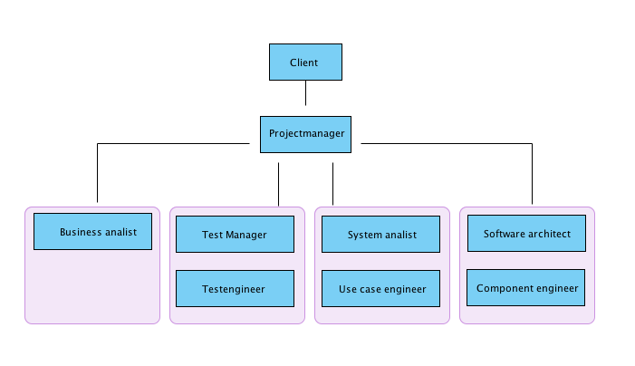

|  |  |
| --- | --- |
|  |  |

The client plays the part of all the roles within the organisation. The project manager is ultimately responsible for the progress of the project. Functions under the management are divided into work groups, thereby making the team management the focus group for the project.

4. Role Descriptions

The project team is divided into four subgroups as outlined below:

|  |  |  |
| --- | --- | --- |
| Role | Leader | Assistant |
| Project manager | Lustenhouwer, Wim | van Damme, Djastin |
| Test manager | Kuijpers, Gideon | Haime, Gary |
| System Analyst | Jansen, Ryanne | Zygnarowski, Kacper |
| Software Engineer | van der Meer, Tim | Munaf, Arif |

The project managers are responsible for the progress of the project. They will lead the various meetings and manage communications with the client (including setting up meetings and relaying reports).

The test managers assure the quality of documents and designs by designing tests for processes and systems.

System analysts analyse the business and its current processes, as well as the processes of the future system. Their main concern will be the system and user requirements.

Software architects design the system based on the requirements and testing techniques. They provide diagrams and models that form the basis on which the software will be built.

5. Quality Management Strategy

5.1 Introduction

The project centres around preparing documents for offshore development, therefore it is imperative that all documents and designs are of sufficient quality. All documents will be reviewed and their quality will be tested.

5.2 Quality Management Procedure

5.2.1 Quality expectations from the clients perspective

* Discipline documents are produced timely.
* Documents are reviewed per RUP iteration and do not conflict with each other.
* The coding company will gain sufficient information from the documentation to successfully build the application.
* Diagrams are properly structured and designed in UML.
* Internal group communications are on a professional level.
* Interaction between the group and organisation will be time efficient and goal oriented.

5.2.2 Acceptation Criteria

* All documents are written in English
* Documents and artefacts are properly organised by disciplines.
* Discipline artefacts are complete and approved by the client.
* Documents are presented to their respective stakeholders.
* Documents are presented on time.

5.2.3 Quality Control

The project will use many of the PRINCE2 concepts to plan, monitor and control the project. To check the quality of a discipline artefact the quality review technique of PRINCE2 or inspection/testing will be used, which must conform to the ISO 9000 norms.

These techniques will be fitted into regular RUP phases and meetings. Errors should be discussed openly within the group.

The team uses Google drive and a glossary to manage a small document management system. This DMS helps keeping order and therefore increases quality.

All documents are collected biweekly in a so-called iteration report. This report enables the organisation to produce feedback, alter any misconceptions and avoid mistakes.

5.3 Roles and Responsibilities

The final responsibility for quality of documents and diagrams lies primarily with the project group manager. The responsibilities for the individual discipline documents are distributed according to the assigned roles described in chapter 5.

The organisation is responsible for providing work locations and the planning of the brainstorm and interview sessions. A go/no-go evaluation will take place in the fourth week after all documents are reviewed by the organisation.

6. Configuration Management Strategy

The purpose of this strategy is to establish how and by whom the products of this project will be managed in such a way that storage of the documentation is secured.

*Configuration Management Procedure*

|  |  |
| --- | --- |
| Planning | Artefacts are assigned for creation or updating during team meetings |
| Identification | Artefacts and discipline names have been predetermined and have been communicated |
| Control | Previous versions of specific documents can be retrieved. This is a standard function of Google Drive |
| Status control | All changes are automatically saved and synced with Google’s servers. Changes are saved and can be retrieved to restore a status. |
| Verification | At the end of each iteration, the project manager double-checks whether the delivered product on Google Drive is of sufficient quality. |

*Change Management Procedure*

|  |  |
| --- | --- |
| Establishing | Detected issues should be reported to the project manager. |
| Reviewing | Important issues will be discussed in the next team meeting. |
| Propositioning | During the team meeting team members will evaluate and recommend solutions for the issue. |
| Decisioning | The project manager decides which option is best to solve the issue. |
| Implementing | The team will take the steps necessary for implementing the solution. |

**Tools and Techniques**

The tool used to implement the configuration strategy is Google Drive.

7. Communication Management Strategy

The project group works on scene and will have daily meetings to discuss the project’s progress. The main method of communication between the project group and the organisation will be personal interviews set up through email. Information given by stakeholders is documented by our secretary. Interviews with different stakeholders are organised by the organisation.

8. Project Plan

A period of 10 weeks is available for completion of the project. Because the first week consists of forming the team and assessing the project and the final week is used for different purposes, only eight weeks remain to reach the goals and construct all the necessary artefacts.

Our planning is based on three major factors:

* The organisation and client
* The application
* The team and its management.

The available time will be divided into two phases based on PRINCE2 principles and RUP management. The first phase is the inception phase (2 weeks). The second and main phase is the elaboration phase (6 weeks). The other two phases from PRINCE2 are not relevant to this project because the project will not be built by this project group.

8.1 Inception phase

The main goal of the inception phase is to gain an understanding of the current situation and to understand the basic requirements and wishes of the organisation. The inception phase is supplemented by the forming of the team and establishing work ethics and team play.

As team forming is no formal requirement nor of any commercial interest to the organization, this will take place in the week preceding the actual project. Establishing and understanding the current situation will be the first two week’s main goal.

8.2 Elaboration phase.

The elaboration phase will take place in the six following weeks. The elaboration phase is consists of three iterations:

* IT-1 Business analysis and forming of requirements
* IT-2 Requirements adjusting and software modelling
* IT-3 Adjusting of software design according to feedback and finalizing software specification

8.2.1 IT-1

The inception phase results in a basic understanding of the organization. IT-1 will expand upon our understanding by means of a brainstorm session and interviews. The brainstorm session will be the basis for the requirements, and interviews will be held to further cement our understanding of the demands of the client.

With proper understanding of the actual requirements and the wishes of the interviewed, we will be able to formulate the requirements for the application. RUP principles dictate that these will be elaborated upon during the entire phase. As such we will leave ample room for adjustments and innovations.

8.2.2 IT-2

With the basic requirements established, our team will start modelling the software. Meanwhile we will return to the organization to relay our understanding of how the software should function. During this iteration we will accept constructive feedback from the customer and adjust as needed.

8.2.3 IT-3

Having established the software architecture and implemented the wishes and requirements of the organization, we will now specify the software to the detail. Here we will establish the design of the graphic user interface as well as all finer details of software including testing models and plans. This will be the last opportunity to get feedback before closing communications and ending the project.

Each iteration consist of two weeks counting a total of six weeks for the elaboration phase. The final week will be a review week. The review week is part of the project in an academical sense but not in a role playing way and as such will be disregarded in this document.

8.3 Timeline

Phases and iterations in a graphic timeline:

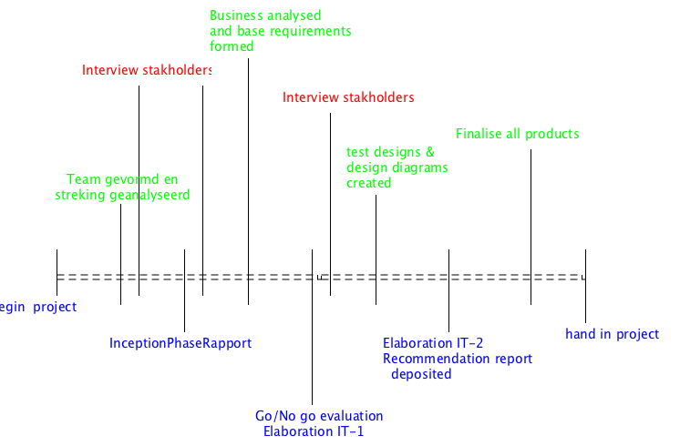

8.4 General planning

Outlined below is the exact schedule week by week:

|  |  |  |  |
| --- | --- | --- | --- |
| **Week 1** | **Week 2** | **Week 3** | **Week 4** |
| Form project group | PID | Update requirements | Analysis discipline |
| Study  Case | Project approach | Update glossary | GUI design |
| Work ethics | Brainstorm session  with stakeholders | Analysis diagram (architectural structure) | Update BUCD |
|  | Interviews stakeholders | UCD + descriptions | Update BAD |
|  | Define base discipline documents | Interviews stakeholders | Update PD |
|  | Base glossary | Functional/non-functional user requirements | Prioritized requirements |
|  | BUCD | Technical constraints? | Requirements final evaluation |
|  | BAD | Functional/non-functional software requirements | Business rules |
|  | PD |  |  |
|  | Inception report |  | Recommendation  report |
|  | System scope |  | Elaboration report iteration 1 |
|  | Description of requirements based on case materials |  | Analysis use case realisations |
|  | Description of requirements based on case materials and interviews |  | actor list |
|  |  |  | navigation map |

|  |  |  |  |
| --- | --- | --- | --- |
| **Week 5** | **Week 6** | **Week 7** | **Week 8** |
| Interview stakeholders | Elaboration report  Iteration 2 | Final recommendation report | Final hand in (Elaboration iteration 3) |
| Test risk analysis | Analysis use case realisations | Detailed instructions concerning the software for the Indian coding company |  |
| Test design | Verification report |  |  |
| Test design | Design class Diagram |  |  |
| Test master plan | Test detail plan |  |  |
| GUI design |  |  |  |
| Sequence diagram |  |  |  |
| State diagram |  |  |  |
| Data model Database |  |  |  |
| Additional requirements information |  |  |  |
| packages |  |  |  |
| Navigation map |  |  |  |
| architectural structure |  |  |  |